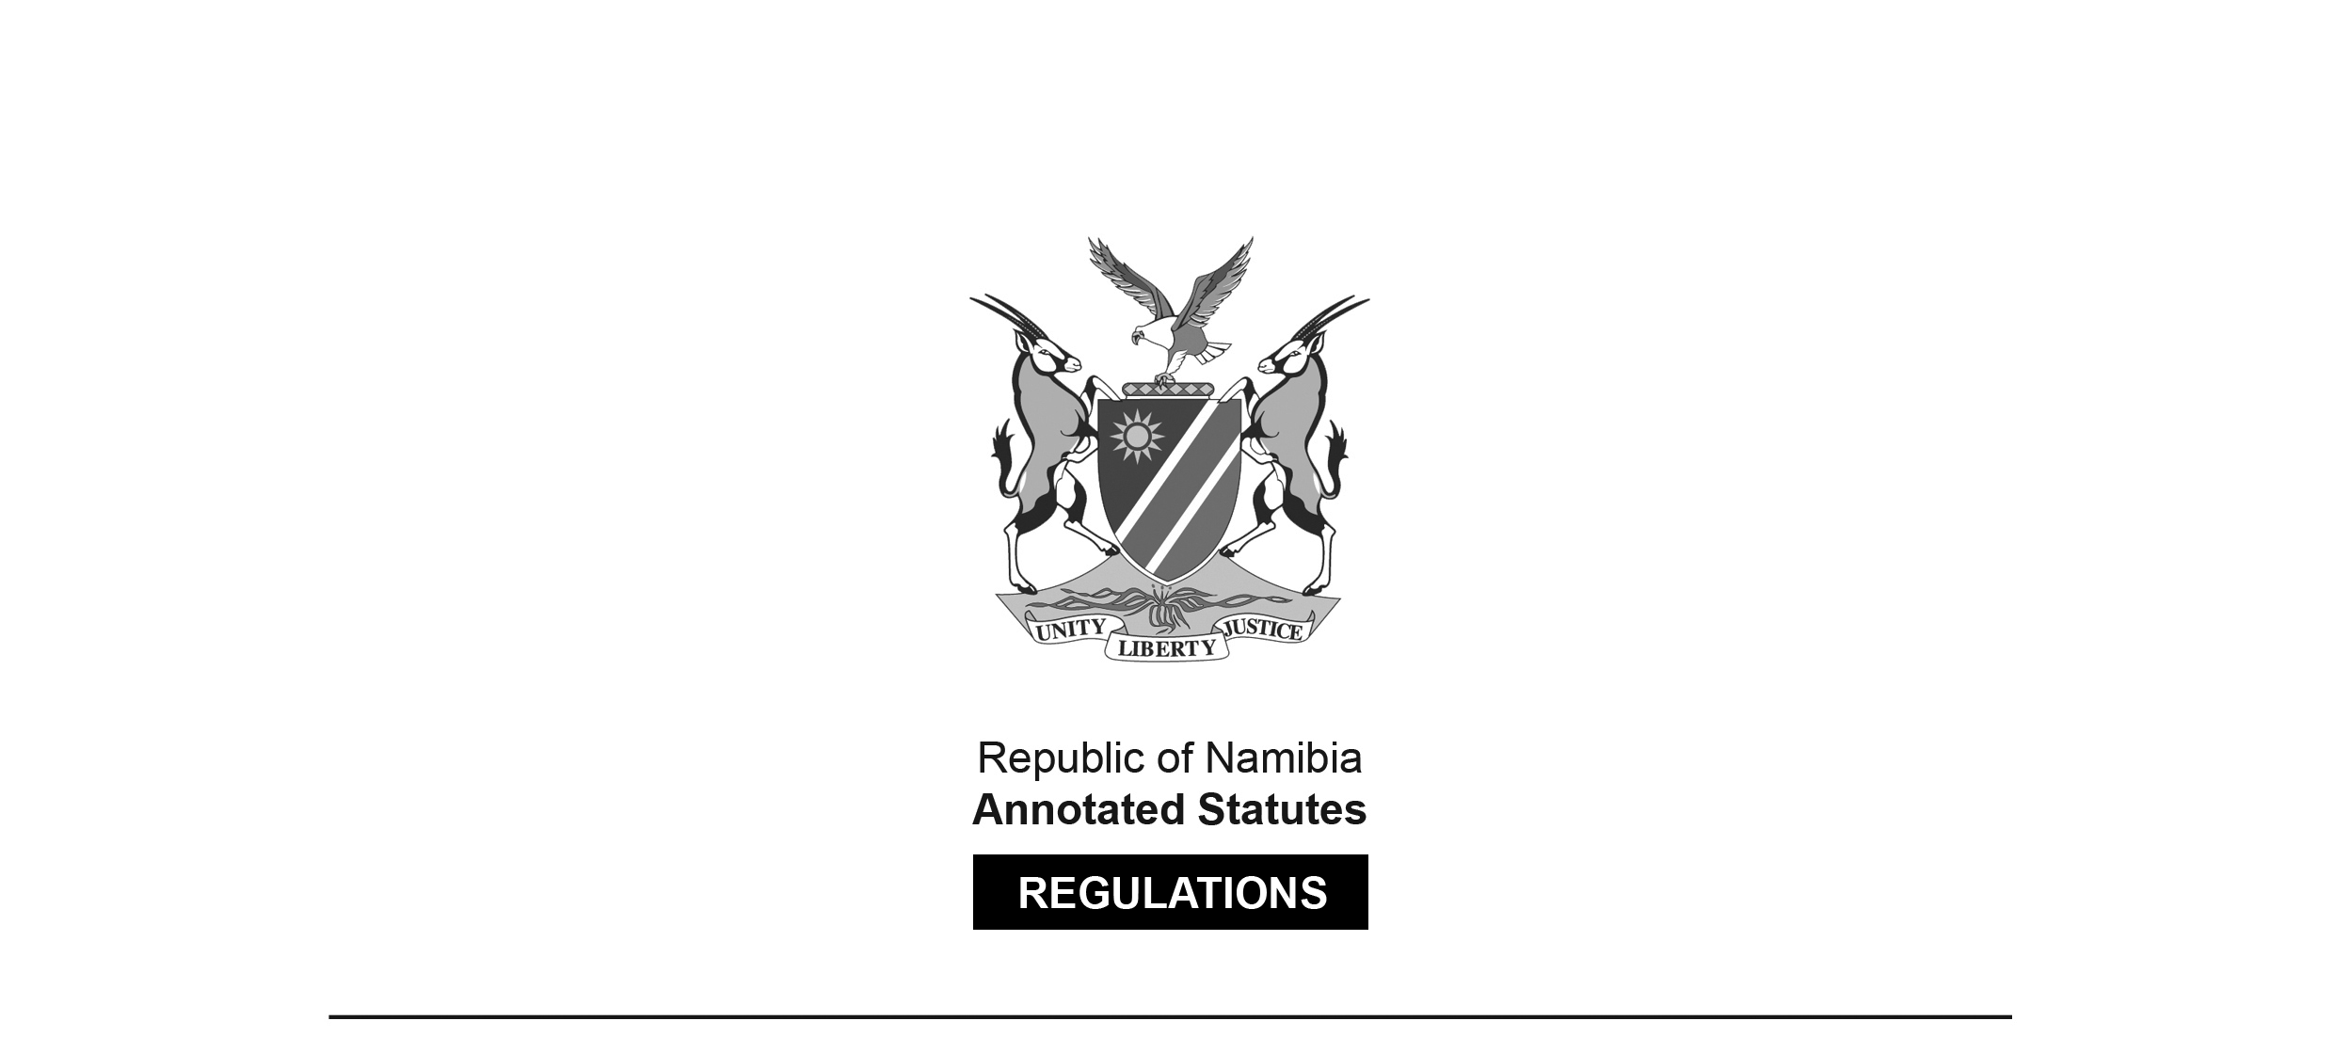
REGULATIONS MADE IN TERMS OF

Health Professions Act 16 of 2024
section 91(1)

Regulations relating to Minimum Requirements and Registration of Oral Hygienists, Additional Qualifications, Maintaining of Register and Restoration of Names to Register and Scope of Practice of Oral Hygienists
Government Notice 60 of 2026
(GG 8861)
came into force on date of publication: 9 March 2026

The Government Notice which publishes these regulations notes that they were made
on the recommendation of the Health Professions Council of Namibia.

It also repeals the Regulations Relating to Minimum Requirements of Study for Registration as Oral Hygienist in GN 144/2008 (GG 4068); the Regulations Relating to Registration of Oral Hygienists, Maintaining of Registers of Oral Hygienists and Restoration of Name to Register in GN 145/2008 (GG 4068); and the Regulations Relating to Scope of Practice of Oral Hygiene in GN 197/2008 (GG 4103), as amended by GN 210/2015 (GG 5831). The repealed regulations were made in terms of section 59 read with section 25 of the Medical and Dental Act 10 of 2004, which was repealed by the Health Professions Act 16 of 2024. Pursuant to section 95(10) of the Health Professions Act 16 of 2024, they were deemed to have been made under that Act.

ARRANGEMENT OF REGULATIONS

1. Definitions
2. Minimum qualifications for registration as oral hygienist
3. Minimum qualifications for registration as oral hygienist to practice independently
4. Application for registration as oral hygienist
5. Registrable additional qualifications
6. Scope of practice of oral hygienist
7. Register of oral hygienist
8. Restoration of name to register
9. Language of forms and documents
Annexure: Additional Qualifications

Definitions

1. In these regulations a word or an expression to which a meaning has been assigned in the Act has that meaning, and unless the context indicates otherwise -

“dentist” means a person registered as a dentist under section 34 of the Act;

“dental specialist” means a person registered as a dentist specialist under section 38 of the Act;

“equivalent qualification” means a qualification obtained after full-time education of similar course and comprising of similar subjects as specified in regulation 2(2) and 3(2);

[The singular word “course” should be the plural word “courses”. The word “of” is superfluous.]

“oral hygienist” means a person registered as an oral hygienist under section 34(5) of the Act; and

“the Act” means the Health Professions Act, 2024 (Act No. 16 of 2024).

Minimum qualifications for registration as oral hygienist

2. (1) Subject to other requirements in the Act, the Council may register a person as oral hygienist if the person holds any of the following qualification:

[The singular word “qualification” should be the plural word “qualifications”.]

(a) Diploma in Oral Hygiene; or

(b) an equivalent qualification,

obtained from an educational institution after the person has successfully completed full-time study for a period of not less than two years.

(2) The curriculum of the qualification referred to in subregulation (1) must include the following subjects -

(a) clinical practice;

(b) oral diseases and prevention;

(c) introduction to clinical practice;

(d) academic literacy for oral health;

(e) applied dental practice;

(f) oral health promotion;

(g) health, development and primary health care;

(h) interdisciplinary health promotion;

(i) radiography;

(j) local anaesthesia and oral surgery;

(k) special patient care;

(l) measurement of health and disease;

(m) community oral health;

(n) ethics and practice management;

(o) health systems; and

(p) applied research.

(3) Despite regulation 3, an oral hygienist with a qualification referred to in subregulation (1) may practice independently if the oral hygienist has submitted documentary proof to the satisfaction of the Council that he or she has -

(a) subject to subregulation (4), served for a continuous period of at least five years under the direct control and supervision of a dentist or dental specialist in Namibia;

(b) obtained a further qualification from an educational institution with an expanded curriculum in oral hygiene in referred to in with regulation 3(2); and

[The phrase “an expanded curriculum in oral hygiene in referred to in with regulation 3(2)” appears to contain superfluous words. It may have been intended to read “an expanded curriculum in oral hygiene as referred to in regulation 3(2)”.]

(c) completed training in First Aid within the last 24 months of submitting documentary proof to the Council.

(4) An oral hygienist referred to in subregulation (3) who has served under the direct control and supervision of a dental specialist must have served not less than six months within the last year of the five-year period referred to in subregulation (3)(a) under the direct control and supervision of a dentist.

Minimum qualifications for registration as oral hygienist to practice independently

3. (1) Subject to other requirements in the Act, the Council may register a person as oral hygienist to practice independently if the person holds any of the following qualifications -

[The word “an” appears to be missing before the term “oral hygienist”.]

(a) Bachelor Degree in Oral Health;

(b) Baccalaureus Sanitatis Oris; or

(c) an equivalent qualification,

obtained from an educational institution after the person has successfully completed full-time study at an educational institution for a period of not less than three years.

(2) The curriculum of the qualification referred to in subregulation (1) must include the following subjects -

(a) clinical practice;

(b) oral diseases;

(c) human biology for oral health;

(d) oral biology for oral health;

(e) oral health promotion;

(f) periodontology for oral health;

(g) measuring health and disease;

(h) pharmacology for oral health;

(i) oral diseases and prevention;

(j) health systems;

(k) radiological diagnosis for oral health;

(l) social sciences for oral health promotion;

(m) health, development and primary health care;

(n) interdisciplinary health promotion;

(o) radiography;

(p) local anaesthesia and oral surgery;

(q) clinical oral health;

(r) special care for oral health;

(s) ethics and practice management; and

(t) applied research.

Application for registration as oral hygienist

4. (1) A person who holds a qualification referred to -

(a) in regulation 2(1) may in terms of section 33 of the Act, apply to be registered as an oral hygienist; or

[There should be a comma after the word “may”
to offset the phrase that follows, as in paragraph (b).]

(b) regulation 3(1) may, in terms of section 33 of the Act, apply to be registered as an oral hygienist to practice independently.

(2) The application must in addition to the documents referred to in section 33, be -

(a) made on form 3 set out in the Annexure to the Regulations prescribing application forms, certificates and licences published under Government Notice No. 26 of 23 February 2026 submitted to the Registrar; and

(b) accompanied by a certified copy of the identity document or passport of the person.

(3) The Council may require the applicant to furnish proof, in the manner that the Council may determine, of the proficiency of the applicant in the English language.

Registrable additional qualifications

5. (1) Subject to section 38 of the Act, the qualification referred to in the Annexure may be registered as additional qualifications for an oral hygienist.

(2) Despite subregulation (1), the Council may recognise other additional qualification not listed in the Annexure and that qualification must be entered against the name of an oral hygienist as an additional qualification, if that additional qualification complies with section 38 of the Act.

[The phrase “other additional qualification” should be
“an additional qualification” to fit the sentence structure .]

Scope of practice of oral hygiene

6. (1) The following acts are falling within the scope of practice of an oral hygienist referred to in regulations 3(1), 2(3) and 2(1), except that the oral hygienist referred to in regulation 2(1) must be under the direct supervision of a dentist or dental specialist -

(a) recording of dental history, examining of patients and charting of patients’ oral and dental status;

(b) assessing patients by means of measuring vital signs, and conducting an oral clinical examination;

(c) preforming of analogue, digital radiography and the taking of clinical photographs;

(d) oral hygiene diagnoses and developing of an appropriate treatment plan relating to the scope of oral hygiene;

(e) advising and educating patients on oral self-care including, but not limited to, mechanical and chemotherapeutic plaque control and tobacco cessation;

(f) advising patient about nutrition and diet, fluorides and anti-microbial agents, excluding antibiotics, in relation to oral disease prevention;

[The singular word “patient” should be the plural word “patients”.]

(g) applying of topical agents such as ascaries-preventive agents, remineralising agents, tooth-desensitising agents, surface anaesthetics and plaque-controlling agents;

(h) applying of pit and fissure sealants and minimally invasive procedures such as a traumatic restorative techniques (ART) and sealant restorations and the placement and removal of rubber dam and matrix bands;

[The word “a” is superfluous in the phrase “a traumatic restorative techniques”.]

(i) performing of debridement, scaling, root-planning, the cleaning of dental implants and the polishing of teeth;

(j) treating of dentine hypersensitivity and cervical abrasion lesions;

(k) polishing and recontouring of overhanging restorations;

(l) applying of topical and local anaesthesia;

(n) assisting oral health care professionals in the performance of basic and advanced clinical procedures;

(o) applying of vital tooth whitening techniques and procedures;

(p) making of a study cast or digital impressions (intraoral scans) to produce vacuum formed mouth guards, night guards and whitening trays;

(q) placing of temporary fillings as an emergency measure; and

(r) taking of impressions.

(2) An oral hygienist referred to in regulations 2(1), 2(3) and 3(1) must perform the following acts pertaining to the scope of practice of oral hygiene under the direct supervision of a dentist or dental specialist -

(a) taking of cytological smears;

(b) splinting of mobile teeth;

(c) applying and removing of periodontal packs;

(d) performing of cephalometric tracings;

(e) relieving of trauma caused by intra- and extra-oral appliances, such as the cutting of distal ends of arch wires;

(f) placing and removal of pre-activated orthodontic appliances, attachments and bands;

(g) placing and removal of elastics and ligature wires; and

(h) placement and activation of arch wires.

(3) The following acts pertaining to the scope of practice of oral hygiene must be performed, by an oral hygienist referred to in regulations 2(3) and (3)(1) in consultation with a dentist or dental specialist and by an oral hygienist referred to in regulation 2(1) under direct supervision of a dentist or dental specialist -

[The comma after the word “performed” is superfluous.
The reference to regulation “(3)(1)” should be “3(1)”.]

(a) removing surgical sutures, take castings and trimmings of study and primary work models and cement space maintainers;

[The word “take” should be “taking” to fit the sentence structure.]

(b) performing of temporary cementing inlays, crowns and bridges;

(c) placing of soft linings in dentures as tissue conditioners;

(d) re-cementing of orthodontic retainers; and

(e) producing vacuum formed retainers.

Register of oral hygienists

7. The register of oral hygienist established and kept in terms of section 46 of the Act must, in addition to the particulars specified by subsection (3) of that section, contain -

(a) Any particulars that Council may determine; and

[The word “any” should not be capitalised.]

(b) any change in the particulars recorded in the register.

Restoration of name to register

8. An application in terms of section 50(1) of the Act for the restoration of the name of an oral hygienist to a register must, in addition to the documents and particulars specified under subsection (4) of that section, be accompanied by -

(a) a certified copy of the identity document or passport of the applicant; and

(b) a certified copy of the registration certificate.

Language of forms and documents

9. (1) Subject to subregulation (2), any document required to be submitted to the Council or the registrar in terms of these regulations must be in the English language.

(2) Any document that is not in the English language must be accompanied by a sworn translation of such document it in the English language.

[The word “it” in subregulation (2) is superfluous.]

ANNEXURE
Additional qualifications (Regulation 5)

Diploma in Health Service Management DHSM Witwatersrand

Magister Scientiae Dentium (MSc. Dentium)

